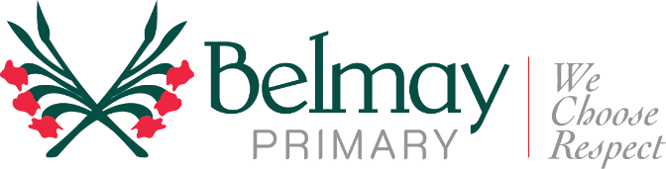
Dear Parents

The students from Pre-Primary to Year 6 will be having a Koora-Middi incursion run by Indigenous Tours WA as part of our National Reconciliation Week activities. Koora-Middi is targeted at primary aged children and focuses on sharing local Aboriginal cultures, histories and perspectives with the students to promote knowledge and reconciliation.

The show allows the students to learn more about:
- Local Aboriginal history and tribal area
- Dreamtime creation story
- Aboriginal Artefacts including items such a kangaroo skins, fire lighting sticks, bush seeds, emu eggs, traditional hunting items and traditional tools.
The show will be presented on Friday June 2nd throughout the day, with each class attending a presentation of the show. The cost will be $2.50 per child.

Please complete the slip below and return to your class teacher by Friday 26th of May.
Thank you
Teachers from PP – 6
Please complete the form below and return it to the class teacher by the due date.
Cut here -------------------------------------------------------------------------------------------------------------------------------------

Consent form: Indigenous Tours WA Incursion Date: Friday 2nd June
I give permission for my child (please print) …………………………………………………..
in class ………. to participate in the ……………………………………………………………

Payment:
I have enclosed payment of $2.50

